**WOBBLE HEAD ASSEMBLY 10/2/2015**

**0) PROGRAM AND TEST CIRCUIT BOARD. (APPLY POWER, BUT NO OTHER CONNECTIONS. USE ICD3. HOLD 5 PIN HEADER WHILE PROGRAMMING)**

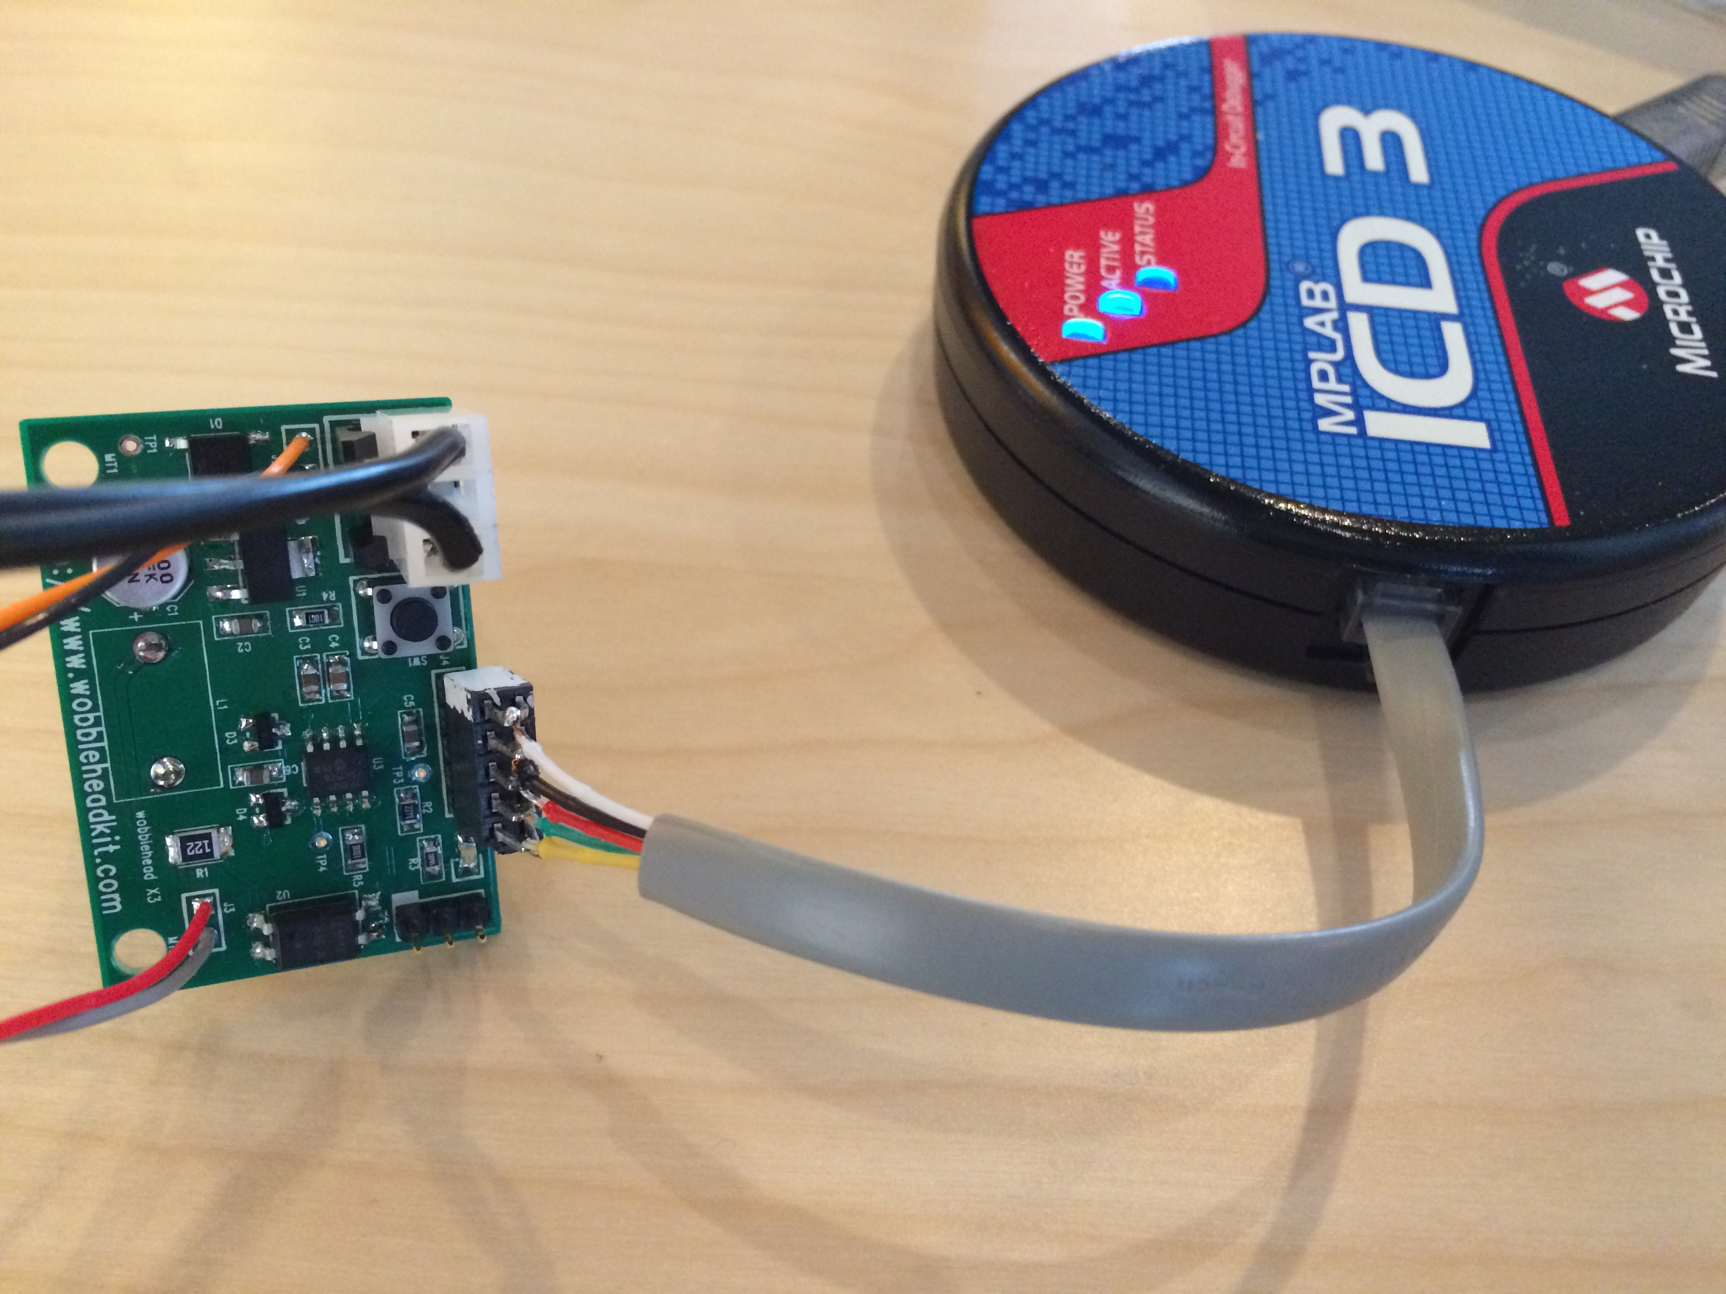

**1) ATTACH SERVO TO PLATE USING QTY 4 8-32 x 3/8” CAP HEAD SCREW**

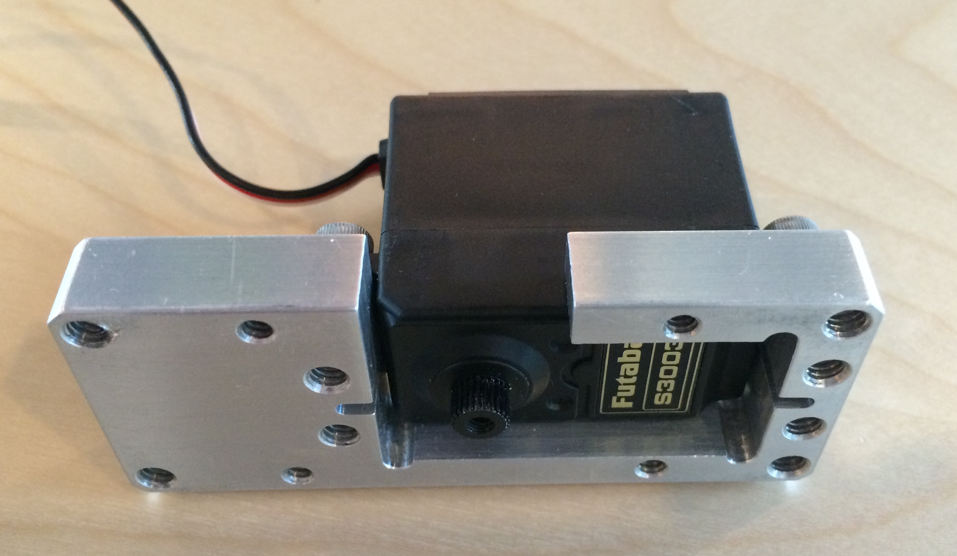

**2 ) LOOSELY ATTACH PCB SCREWS QTY 2 6-32 x 3/8” CAP SCREW**

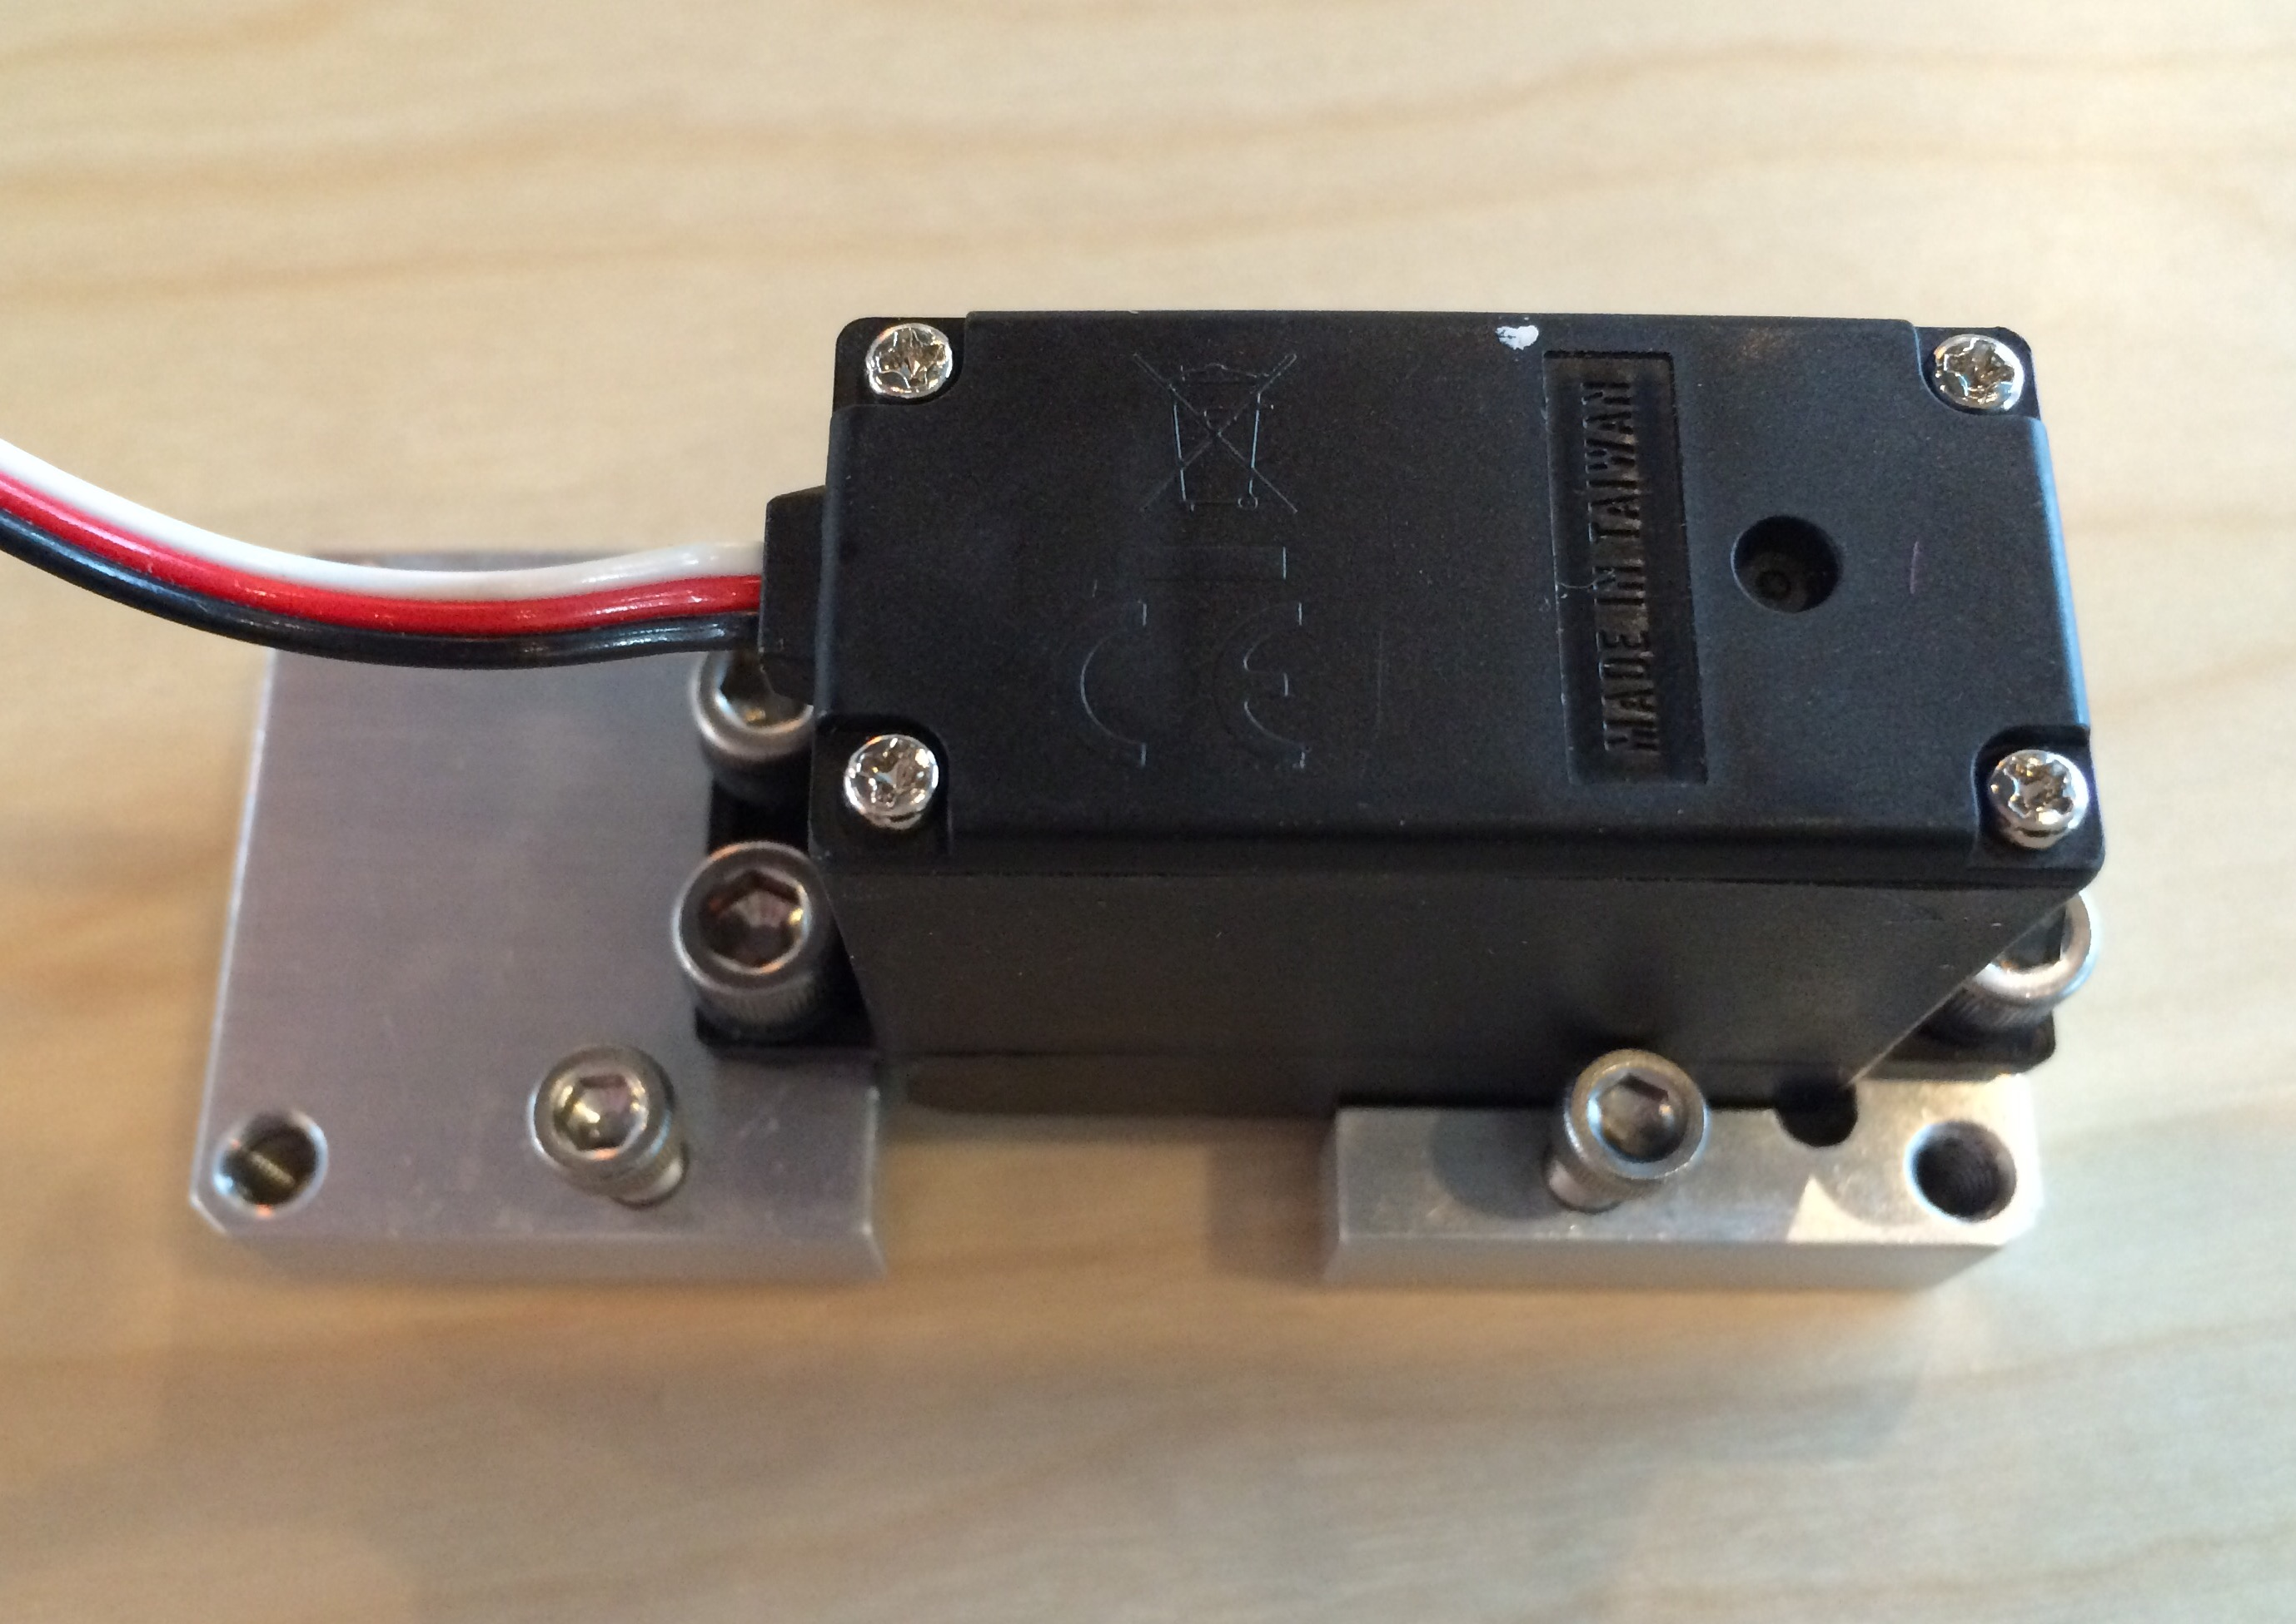

**3) LOOSELY ATTACH MOUNTING SCREWS QTY 4 8-32 X ½” FLAT SCREW**

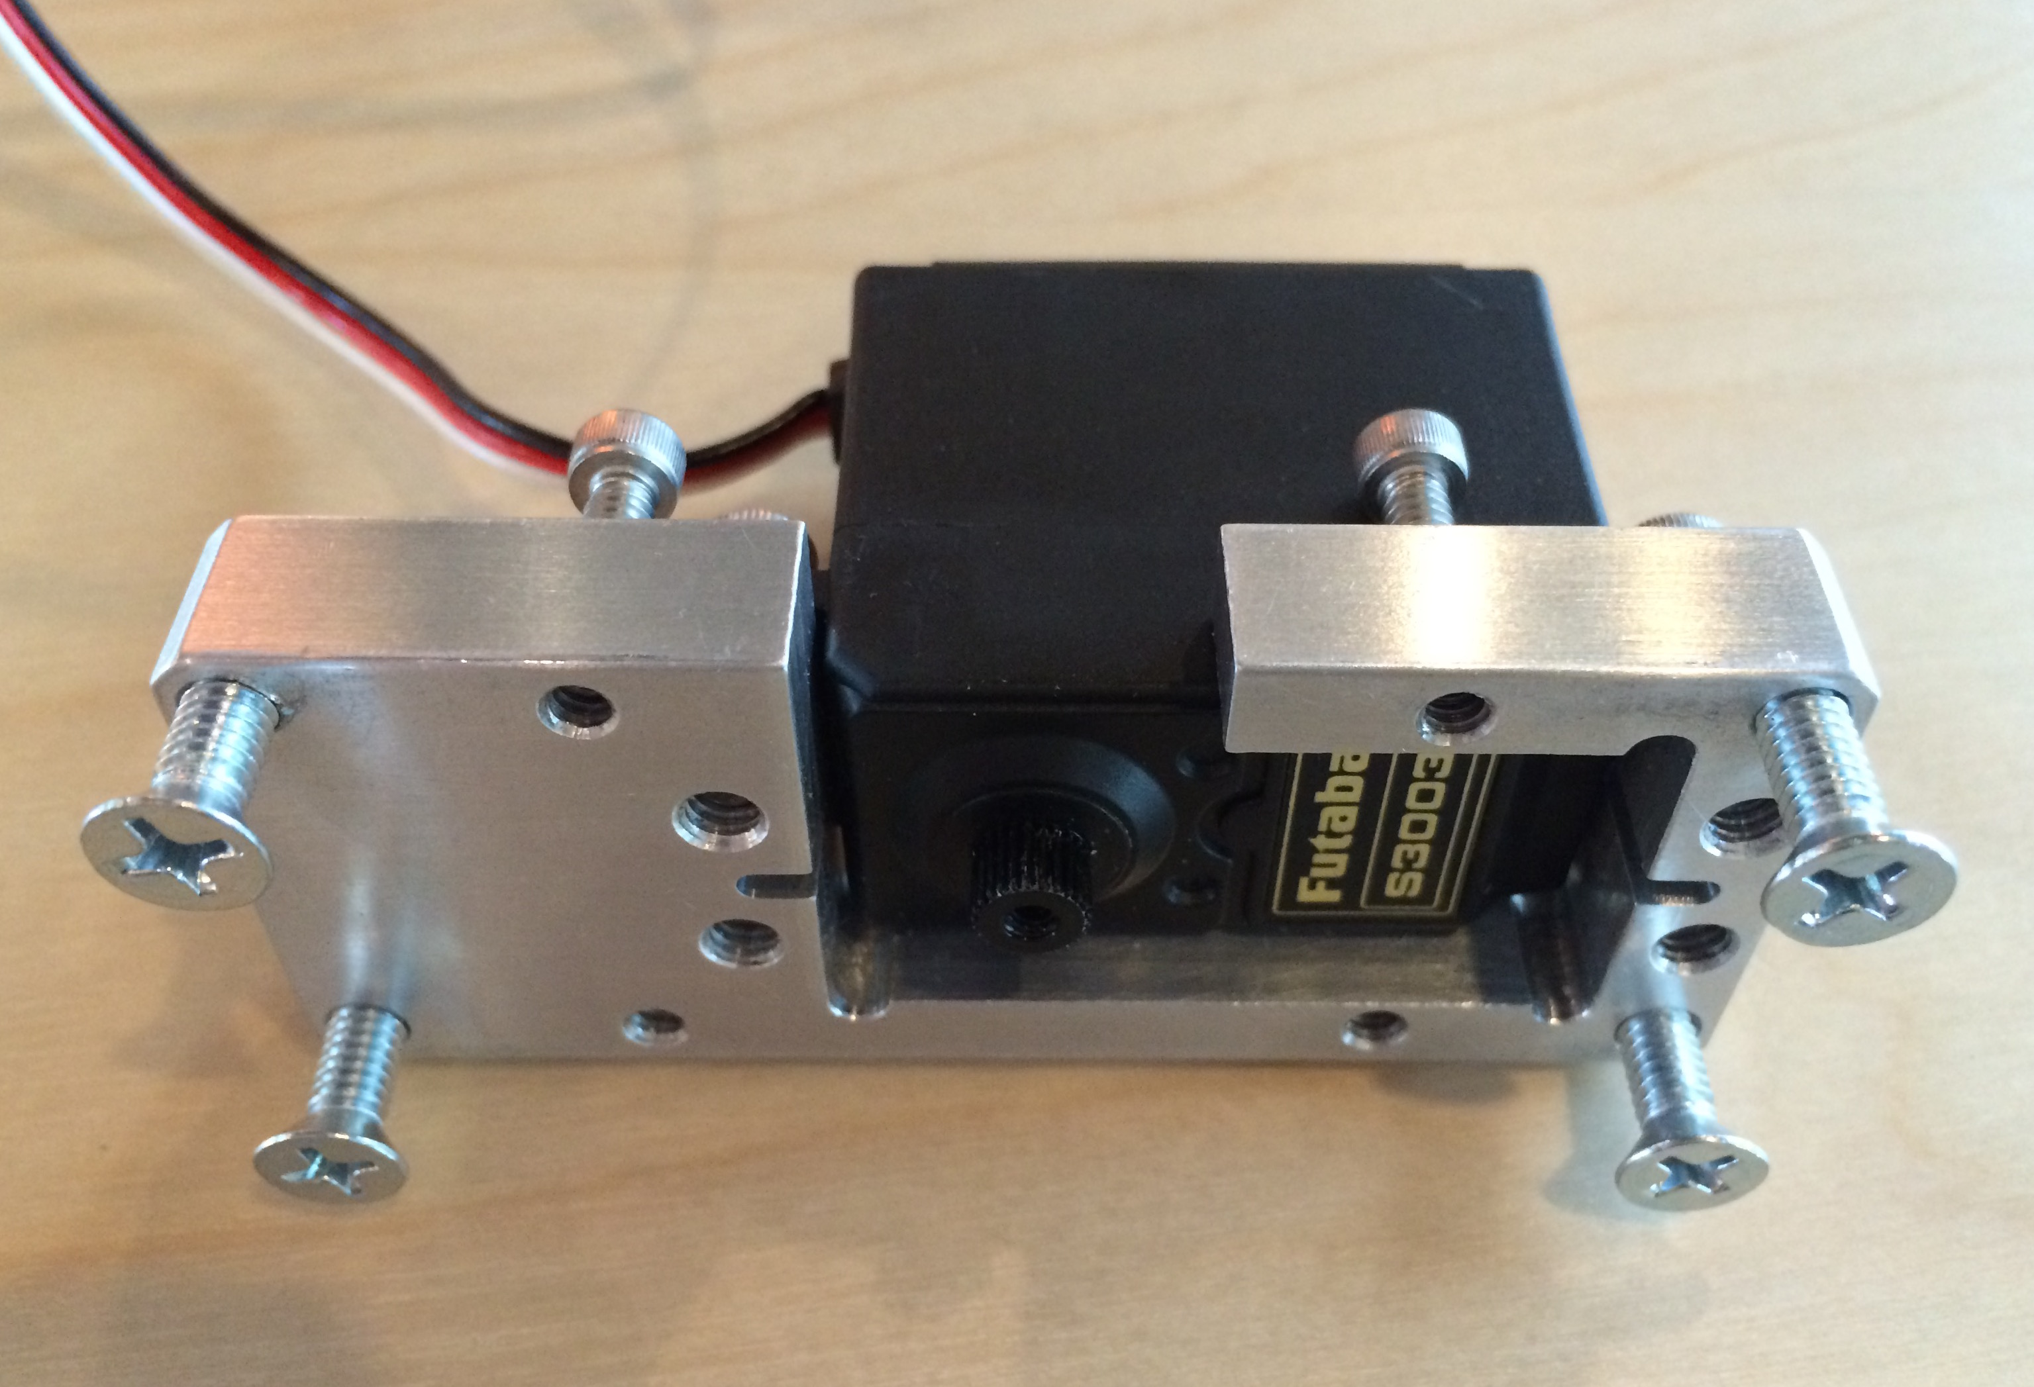

**4) CONNECT SERVO TO 3PIN ON PCB (WHITE CABLE TO WHITE PIN)**

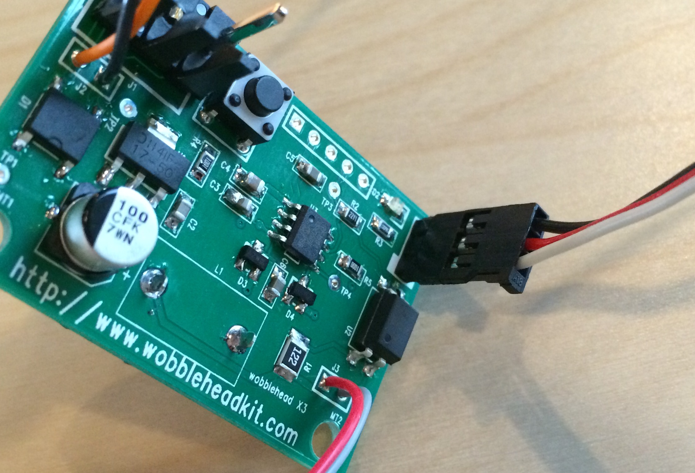

**5A ) POWER PCB. CHECK FOR BLINKING LED (1/SEC). CHECK FOR SERVO CENTER.**

**5B) INSTALL WHITE PLASTIC SPLINE AND PLASTIC HUB. HOLES IN HUB ARE PARALLEL TO LONG EDGE OF PLATE.**

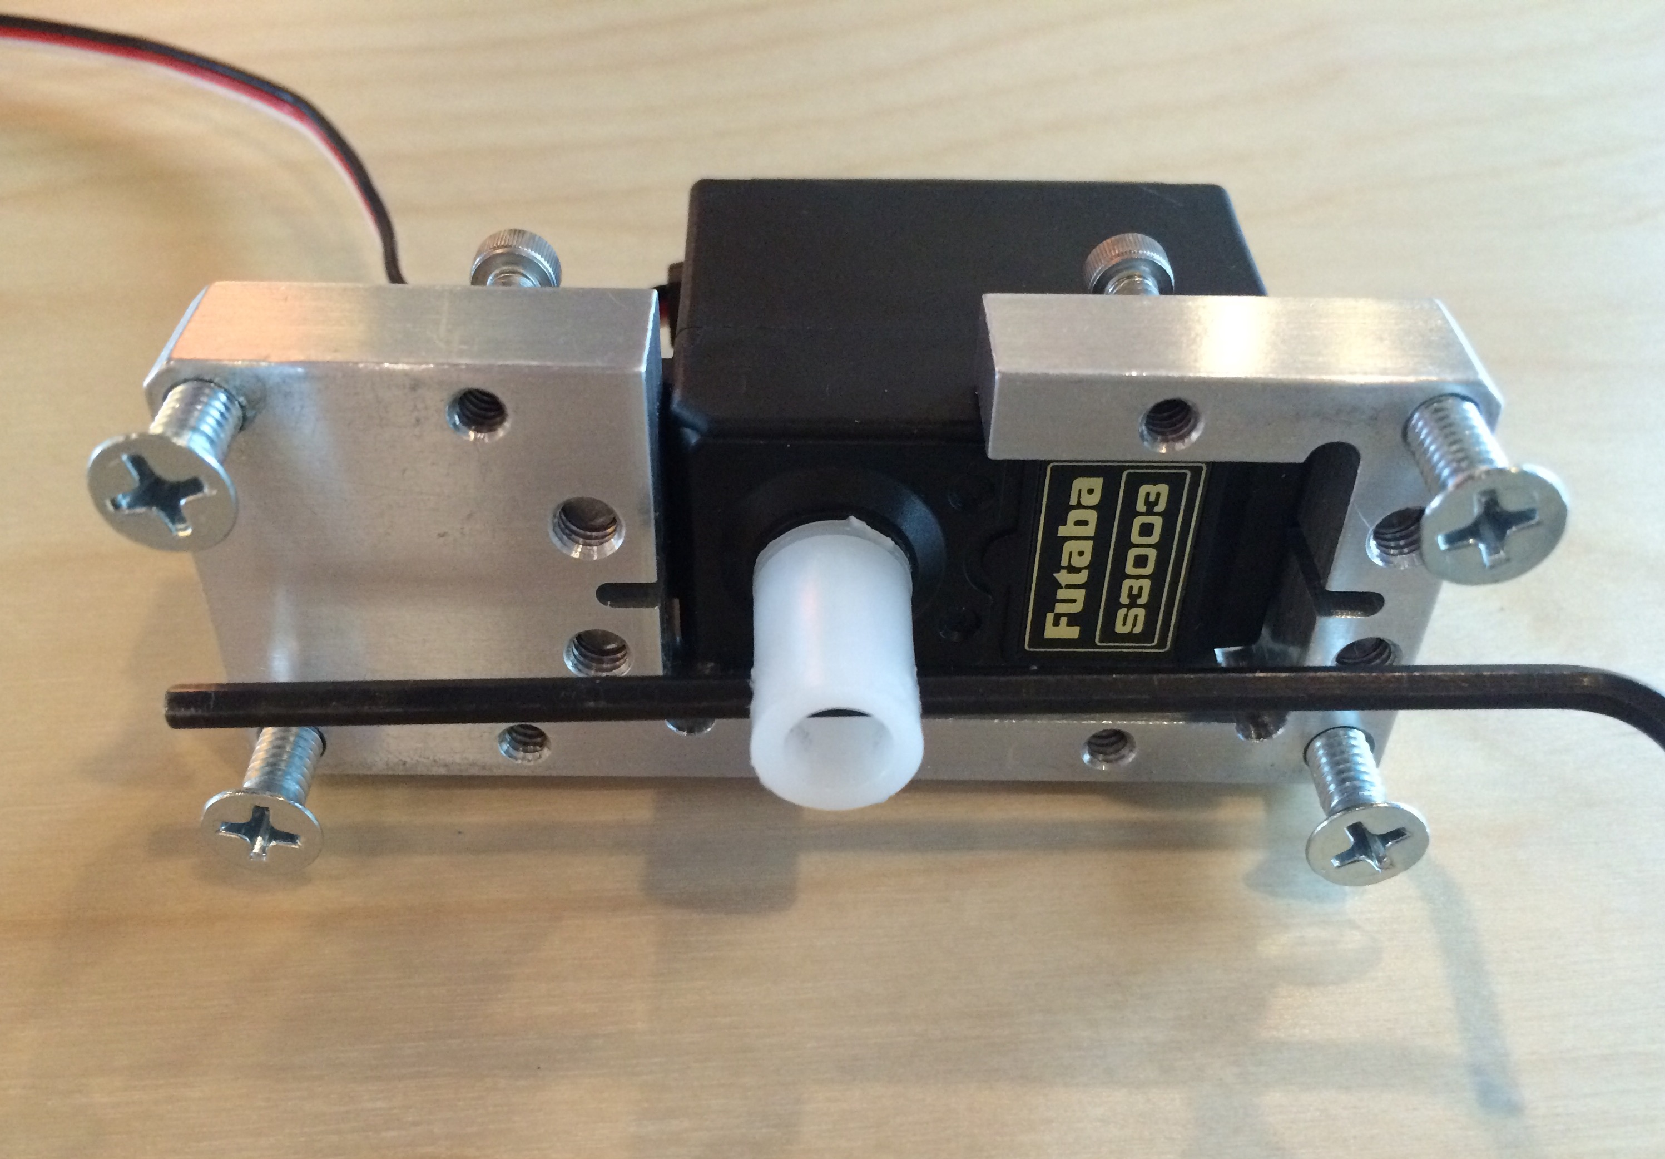

**6) INSERT BLACK SMALL SCREW TO FIX SPLINE TO SERVO.**

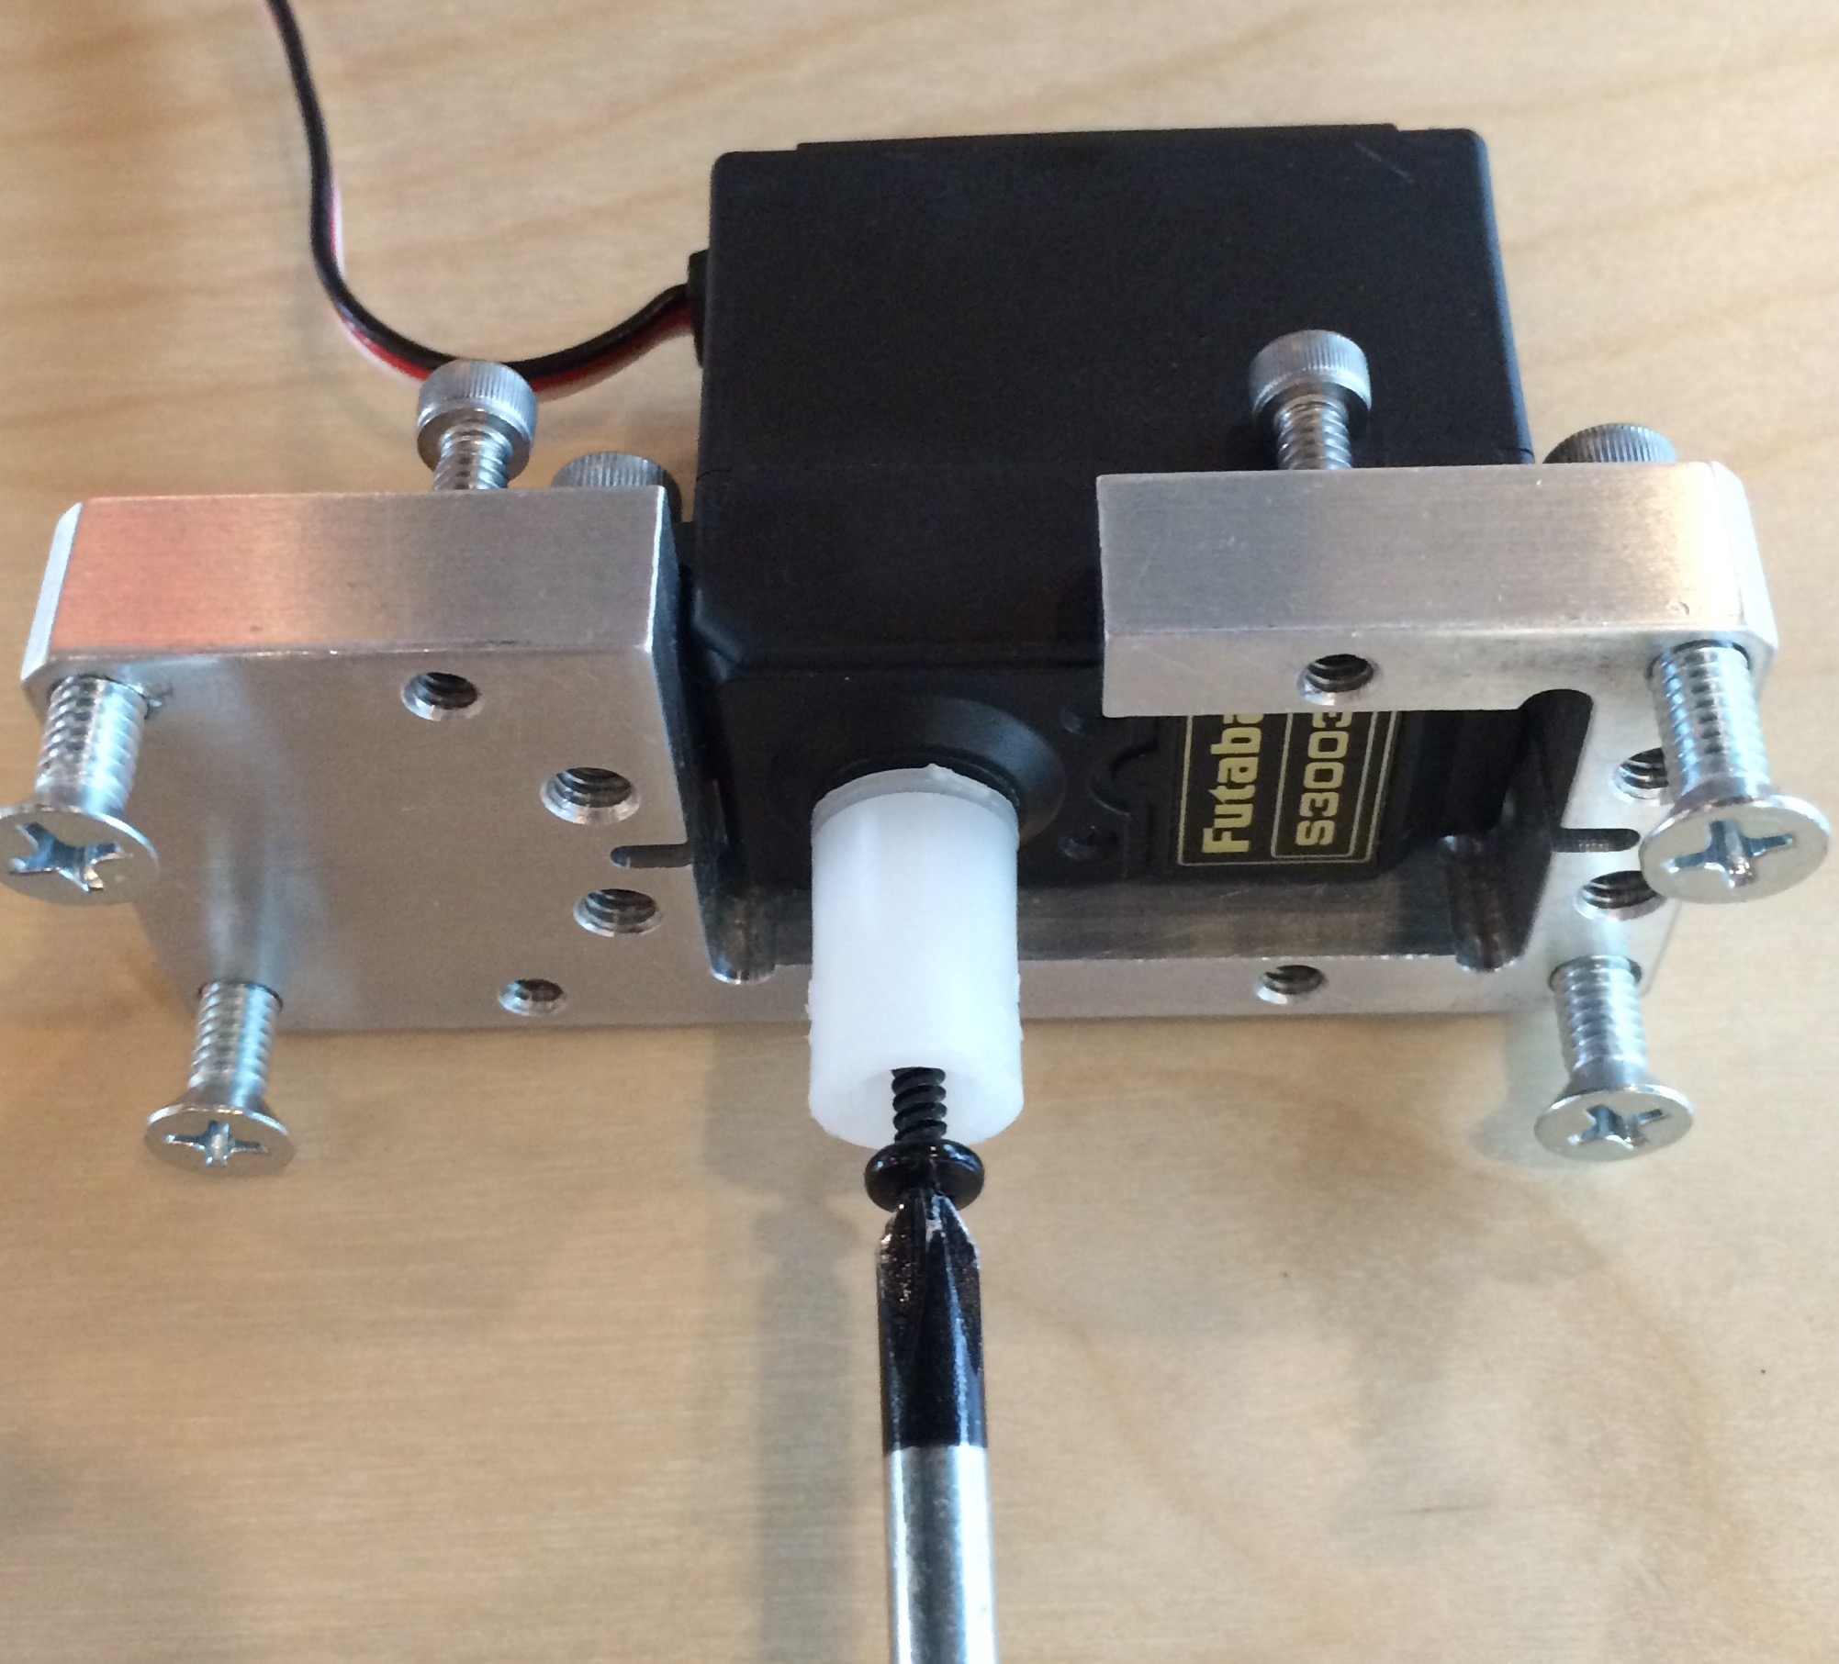

**7) INSTALL METAL ROD TO PLASTIC HUB W/ QTY2 BLACK SET SCREWS**

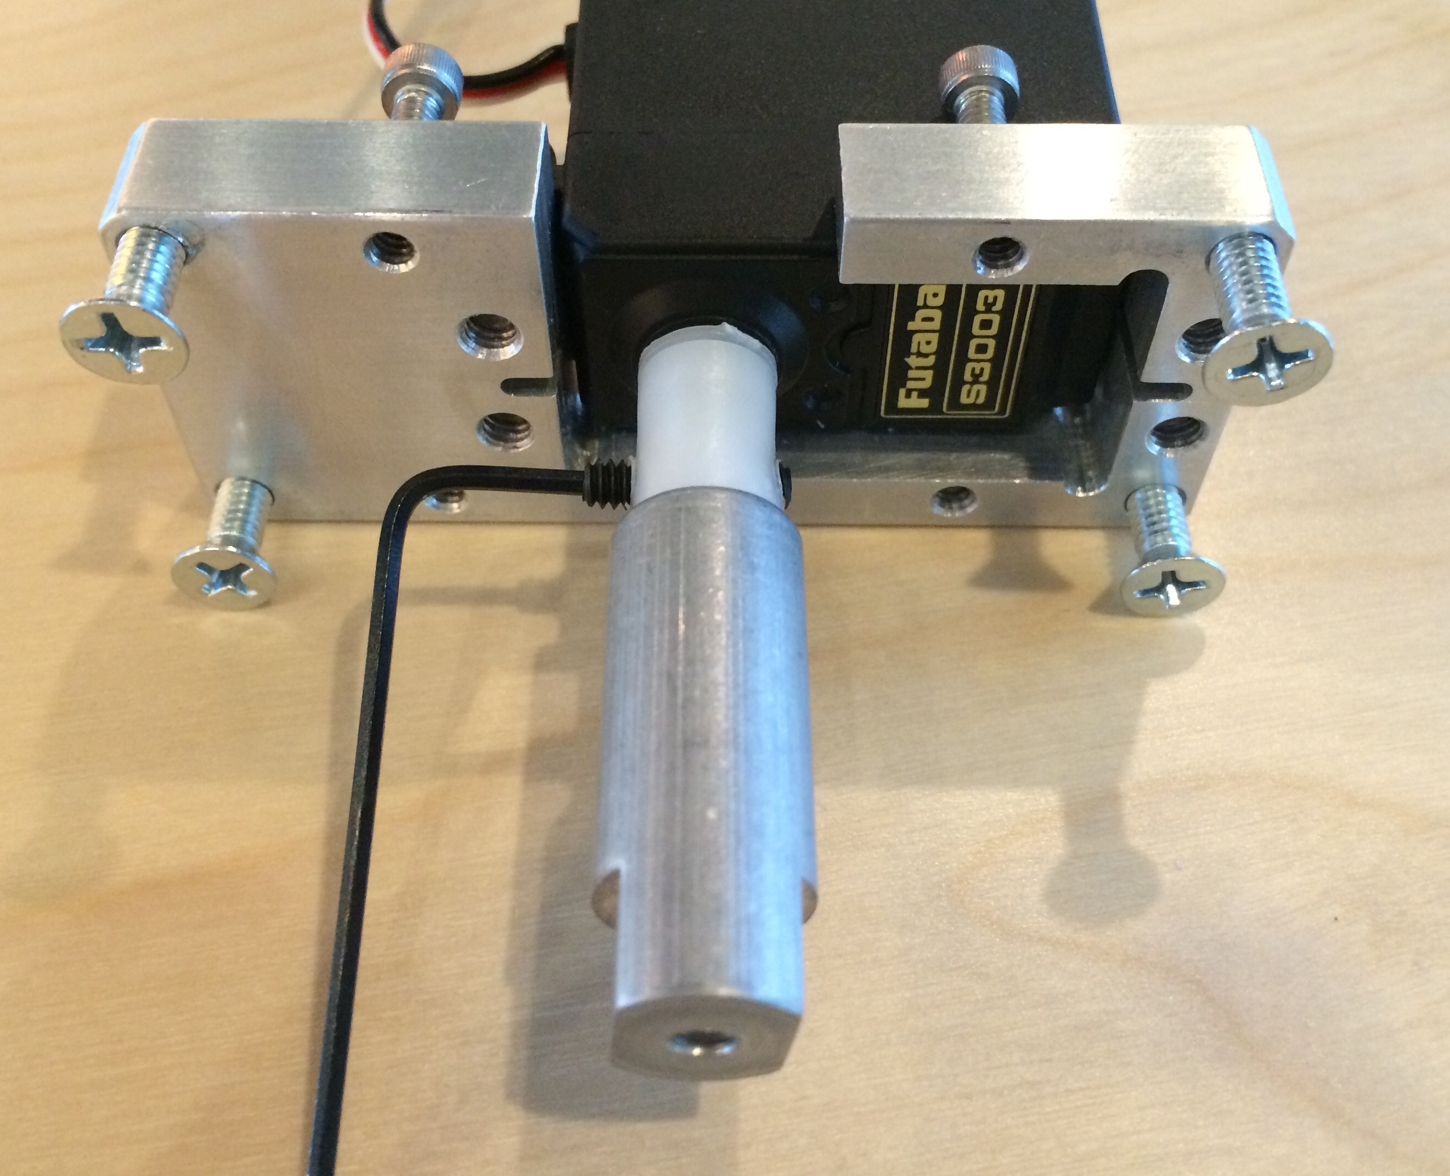

**8) INSTALL ANGLE BRACKET, FENDER WASHER AND 8-32 X1/2” PAN HEAD**

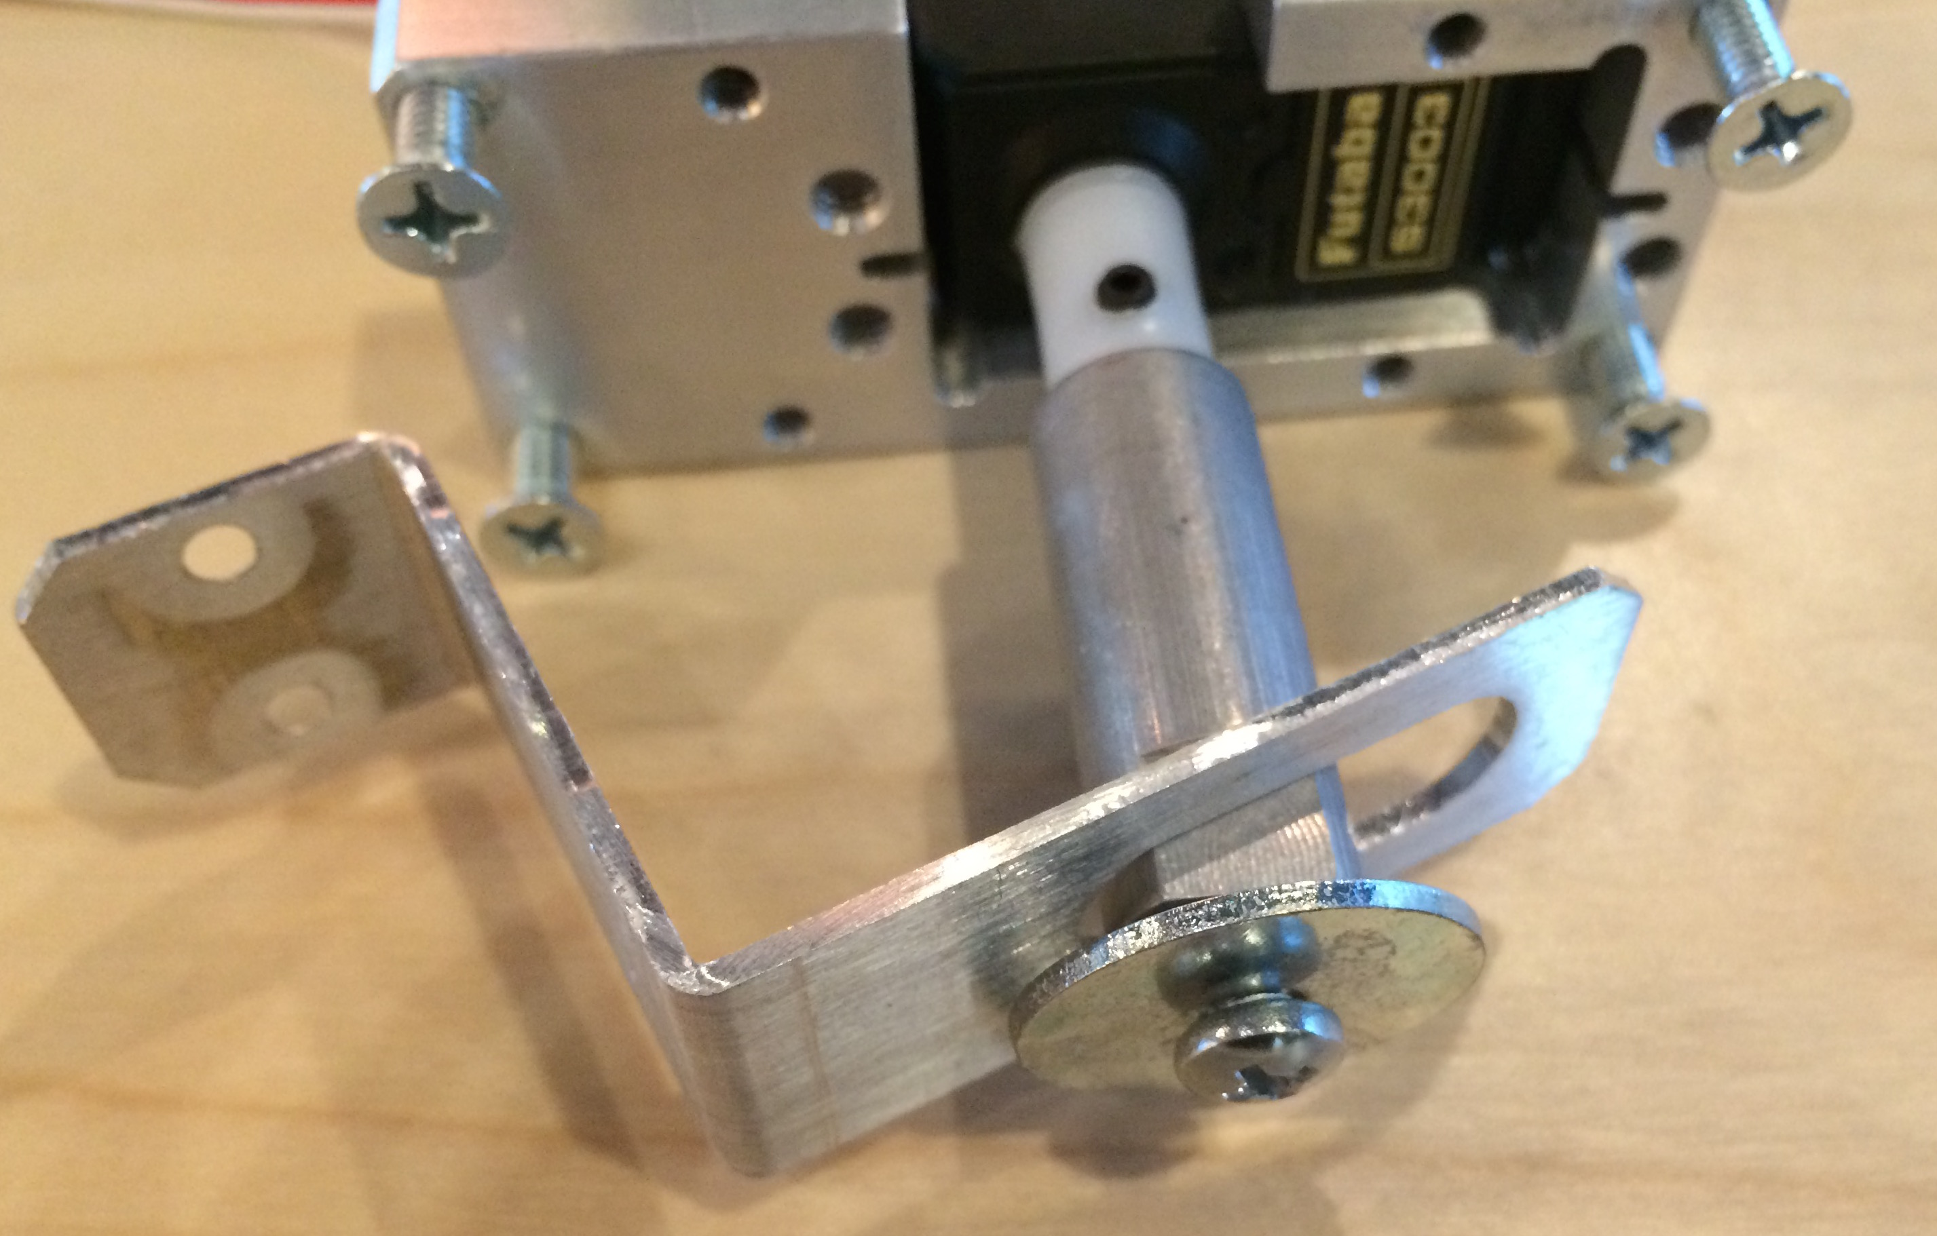

**9) INCLUDE NOTE W/ QTY #4X1/2” SHEET SCREWS**

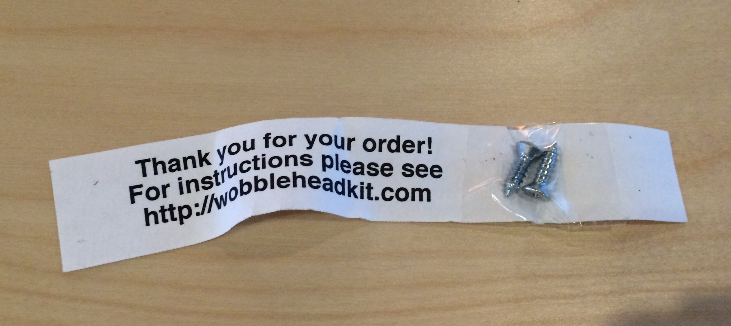

**10) PACK**